**Roll No.:** 16010122221 **Batch:** Comp-B2

**Experiment No. 01 Name: Akshat**

**Grade: AA / AB / BB / BC / CC / CD /DD**

**Signature of the Staff In-charge with date**

**Instructions for Experiment 1 Study of Cloud Computing & Architecture**

Study the types of computing, NIST(3-4-5) Definition for Cloud, 5 Essential Characteristics of Cloud, Various cloud deployment models, service models and the evolution of cloud computing. Studying various file service storage providers that offer cloud storage, file synchronization and client software.

List the common features included in DAAS.

Explore any 5 Desktop-as- a-Service and include the corresponding screenshots in the writeup. Perform a comparative analysis of all of them.

# Further prepare a comparative analysis table with respect to Price, Mobile App Availability, Storage Space, UI, Sharing capabilities via Social media/Mail, Chat facility

Some of the Daas are listed as follows:

* [www.cloudtop.com](http://www.cloudtop.com/)
* [www.cloudme.com/en-free](http://www.cloudme.com/en-free)
* [www.eyeos.com](http://www.eyeos.com/)
* [www.qubes-os.org](http://www.qubes-os.org/)
* doky.io
* Universeos.org
* [www.ubidesktop.com](http://www.ubidesktop.com/)
* 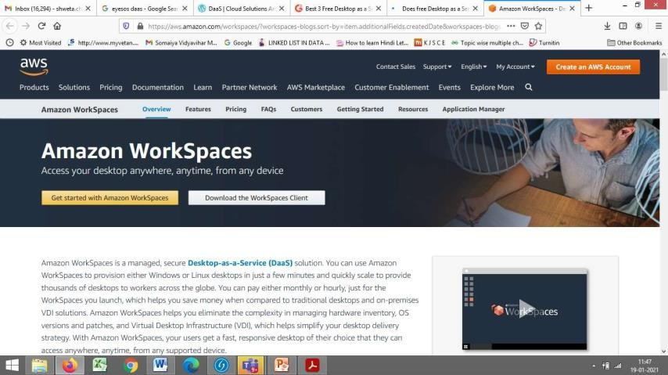amazon workspaces-(paid)

Students are free to explore any other DaaS as well. Also, Compare and contrast between Daas and Iaas

CC-4 Batch found out-

**neverinstall.com-free one**

**kasmweb.com-not free,only demo version for 3 mins**

1. **CloudTop**
   * **Website**: [www.cloudtop.com](http://www.cloudtop.com/)
   * **Overview**: CloudTop offers a complete cloud-based virtual desktop experience. It’s a platform that enables users to access desktops remotely, running on virtual machines hosted in the cloud. This service is mainly targeted at users who need a secure, customizable environment for work, education, or personal use.

# Key Features:

* + - Cloud-based virtual desktops.
    - Easy web access for virtual desktops.
    - Support for multiple devices including Windows, Mac, iOS, and Android.
    - Customizable virtual desktops with app support.
    - Multi-user support.
    - File synchronization and cloud storage integration.
  + **Pricing**: Varies based on user requirements. Offers paid plans with custom pricing depending on the number of users and features.

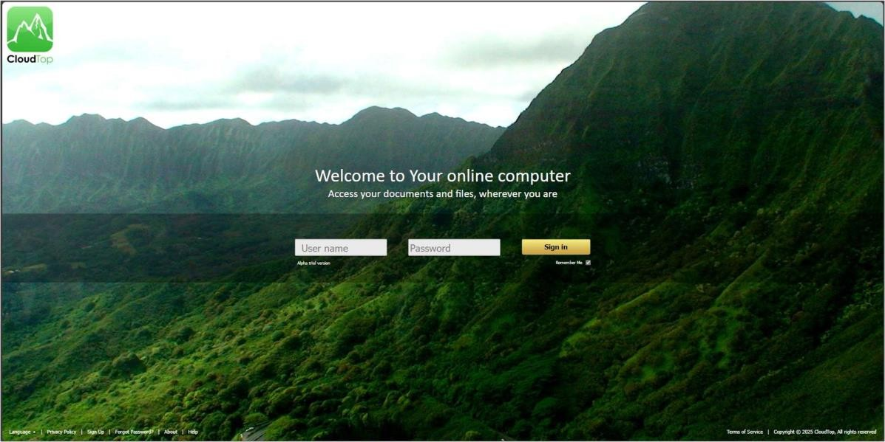

# CloudMe

* + **Website**: [www.cloudme.com/en-free](http://www.cloudme.com/en-free)
  + **Overview**: CloudMe is primarily a cloud storage and synchronization service but also offers cloud desktop features. The free plan gives you access to cloud storage and

synchronization across multiple devices, while premium plans provide additional features and more storage.

# Key Features:

* + - 20 GB of free cloud storage.
    - Multi-device synchronization across Android, iOS, and desktop platforms.
    - Integrated with other cloud services for storage sharing.
    - Web-based file management.
    - Desktop as a Service features, allowing you to access files remotely.
    - Social media and email sharing capabilities.

# Pricing:

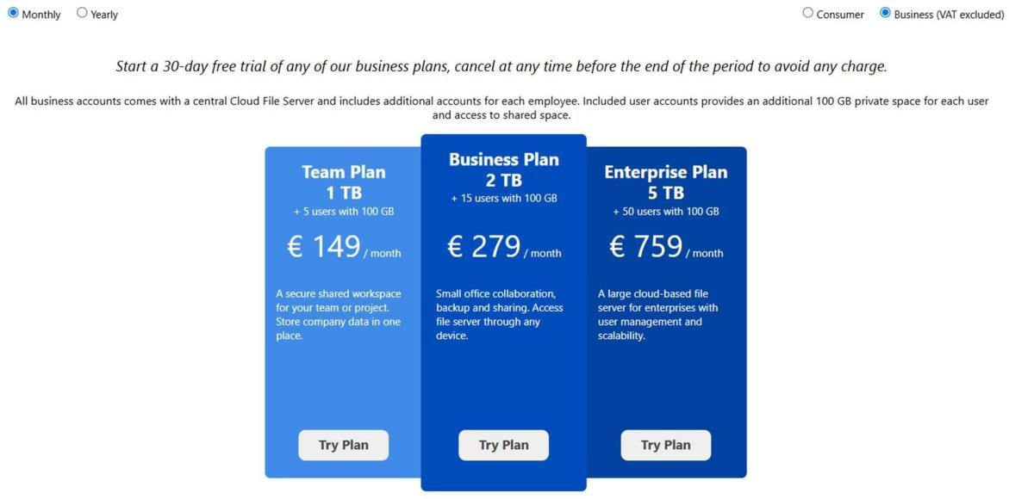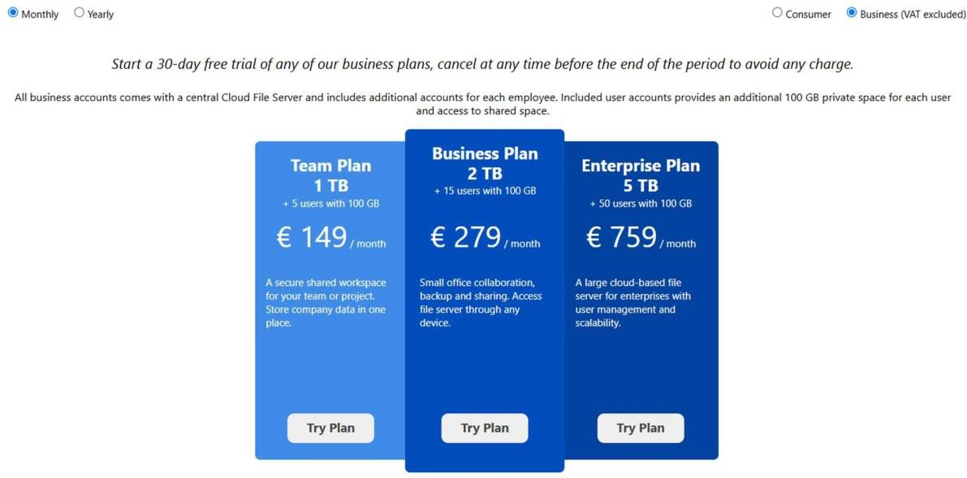

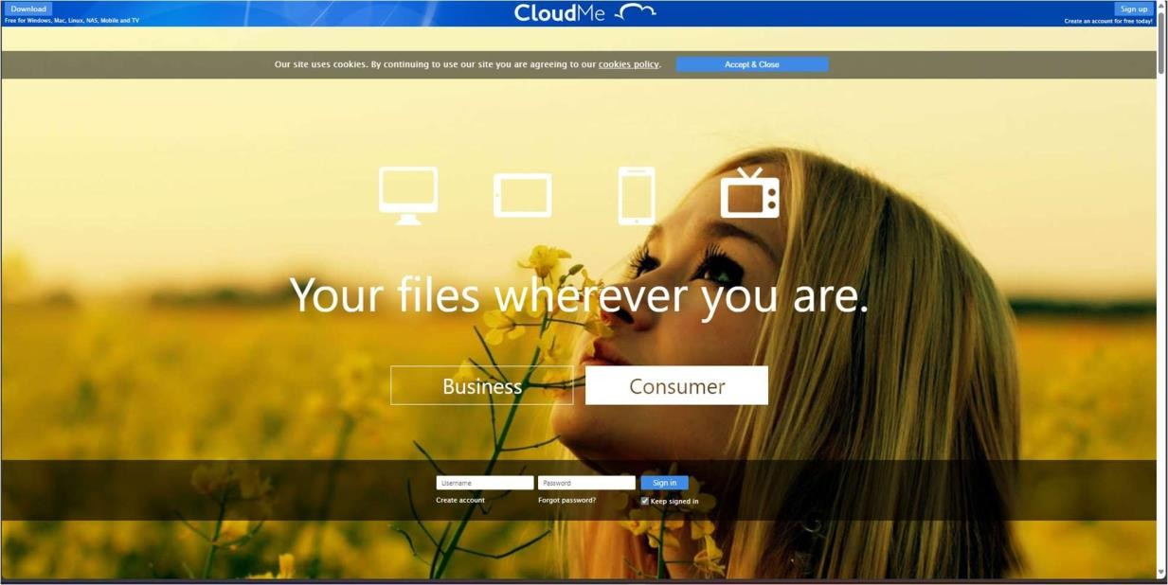

1. **Qubes OS**
   * **Website**: [www.qubes-os.org](http://www.qubes-os.org/)
   * **Overview**: Qubes OS is a security-focused operating system designed to provide robust isolation through virtualization. While not a traditional DaaS, it can be used to create isolated virtual machines (VMs) for secure desktop usage, making it an excellent option for privacy-conscious users.

# Key Features:

* + - Security-focused with virtual machine isolation.
    - Uses Xen-based virtualization to isolate different environments.
    - Can run different operating systems in isolated VMs, such as Windows and Linux.
    - Open-source and free to use.
    - Ideal for users who need extreme security but might not be suited for general DaaS use cases.
  + **Pricing**: Free (open-source).

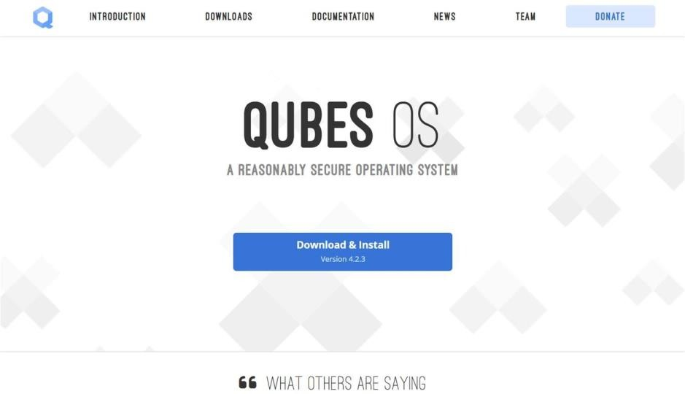

# UniverseOS

* + **Website**: [www.universeos.org](http://www.universeos.org/)
  + **Overview**: UniverseOS is a cloud-based operating system that delivers a seamless virtual desktop experience. Users can run their applications and access files via the cloud, making it ideal for users needing a versatile and customizable virtual desktop.

# Key Features:

* + - Cloud-based desktop environment.
    - Supports integration with popular cloud storage providers.
    - Customizable apps and desktop layout.
    - Provides secure access to virtual desktops from any device.
    - Focus on privacy and encryption.
  + **Pricing**: Free for basic features; premium plans are available for more advanced usage.

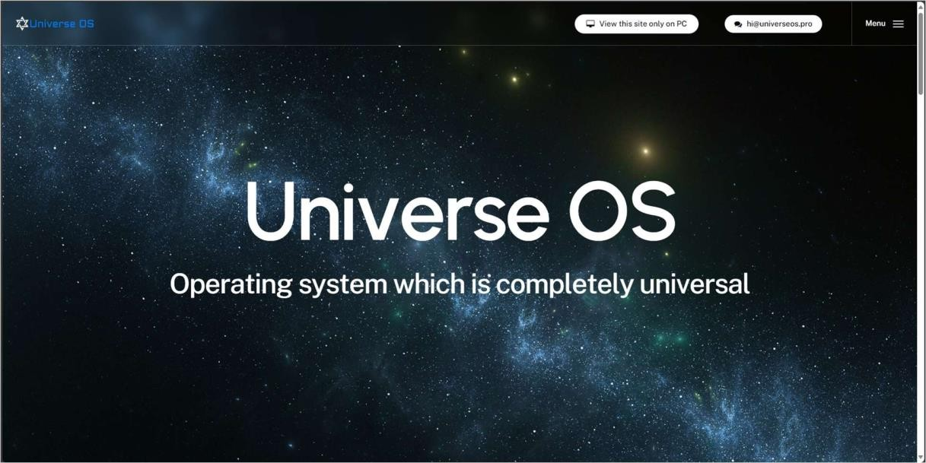

# UbiDesktop

* + **Website**: [www.ubidesktop.com](http://www.ubidesktop.com/)
  + **Overview**: UbiDesktop offers a cloud-based desktop solution with virtual desktop capabilities. It is designed to provide an easy-to-use platform for individuals and businesses to manage their remote desktops effectively.

# Key Features:

* + - Virtual desktop service with a user-friendly interface.
    - Easy access to cloud storage, files, and applications.
    - Secure data encryption and multi-factor authentication.
    - Works across all platforms (Windows, Mac, Linux, Android, iOS).

# Pricing:

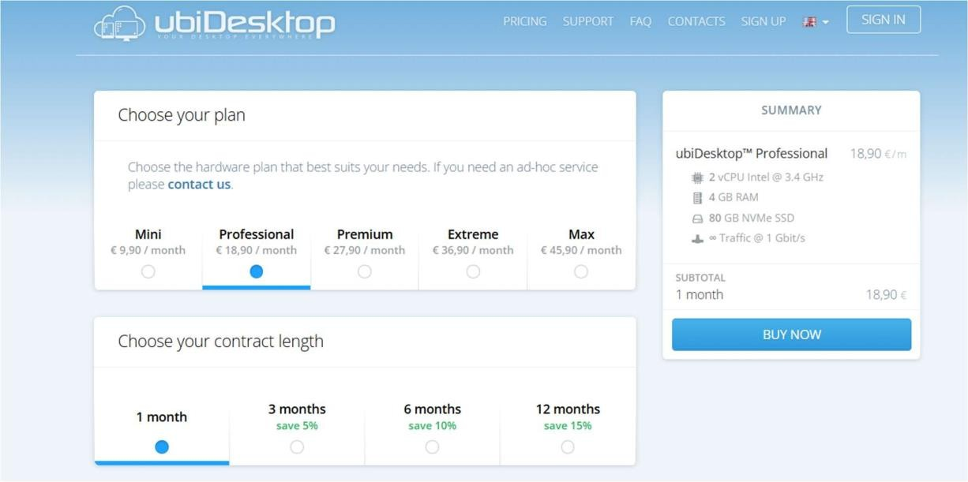

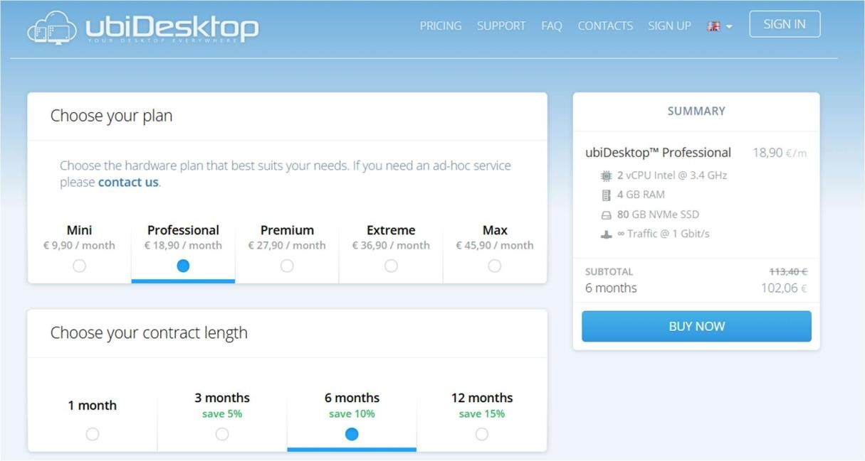

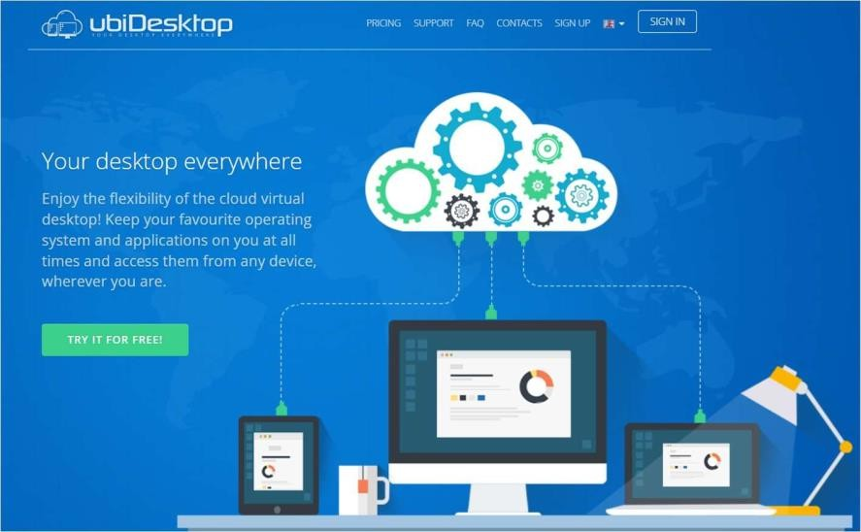

1. **Amazon Workspaces**
   * **Website**: Amazon Workspaces
   * **Overview**: Amazon Workspaces is a fully managed Desktop-as-a-Service (DaaS) offering from Amazon Web Services (AWS). It allows businesses to deploy and manage cloud desktops for their users, providing virtual desktops in a highly scalable and secure environment.

# Key Features:

* + - Managed virtual desktops in the AWS cloud.
    - Support for both Windows and Linux desktops.
    - Integrated with other AWS services.
    - Fully customizable virtual desktops for different use cases.
    - Strong security with encryption and compliance support.
    - Easily scale to support large numbers of users.

# Pricing:

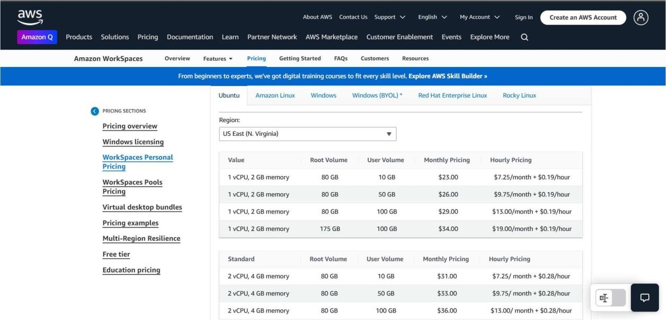

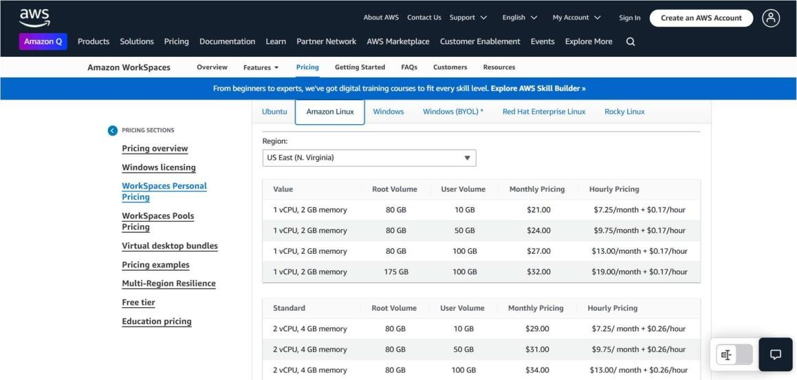

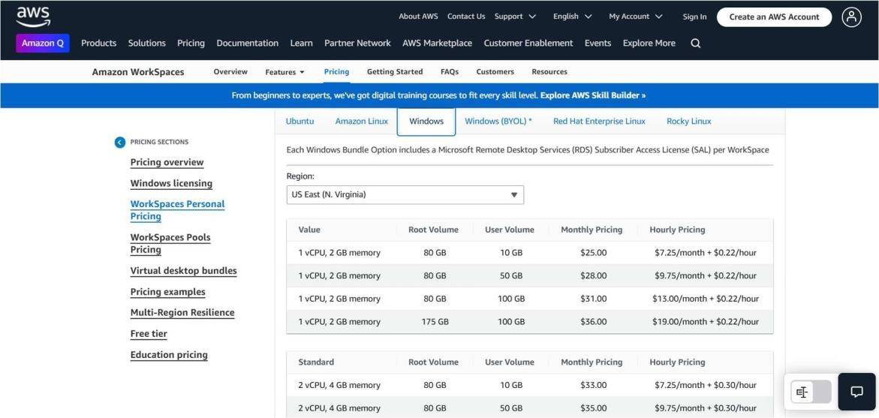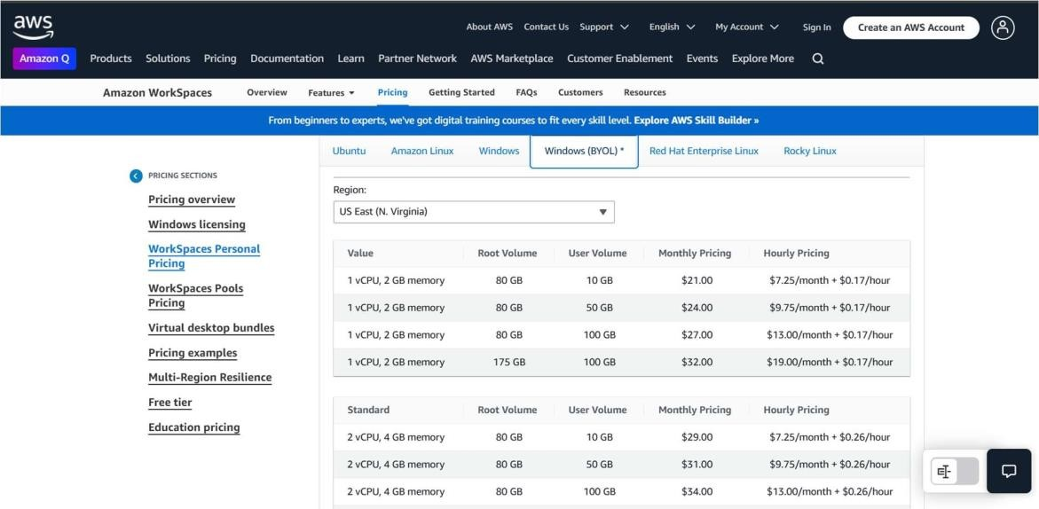

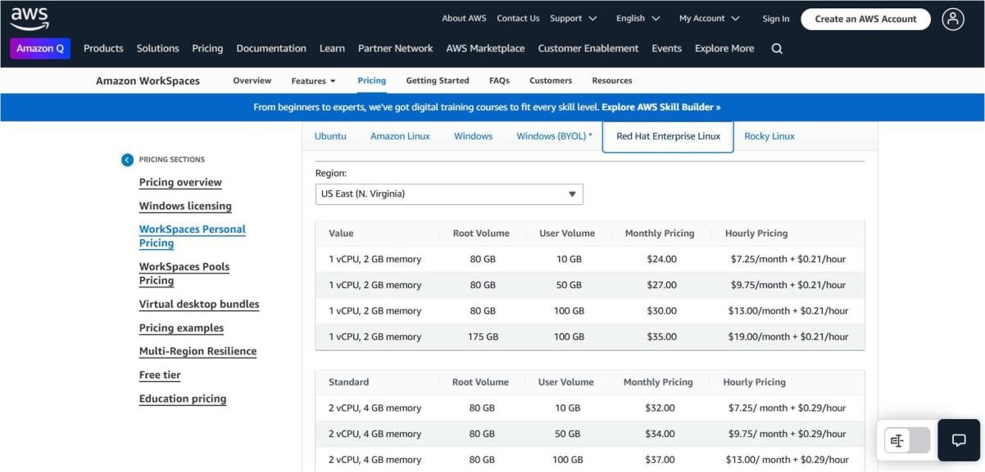

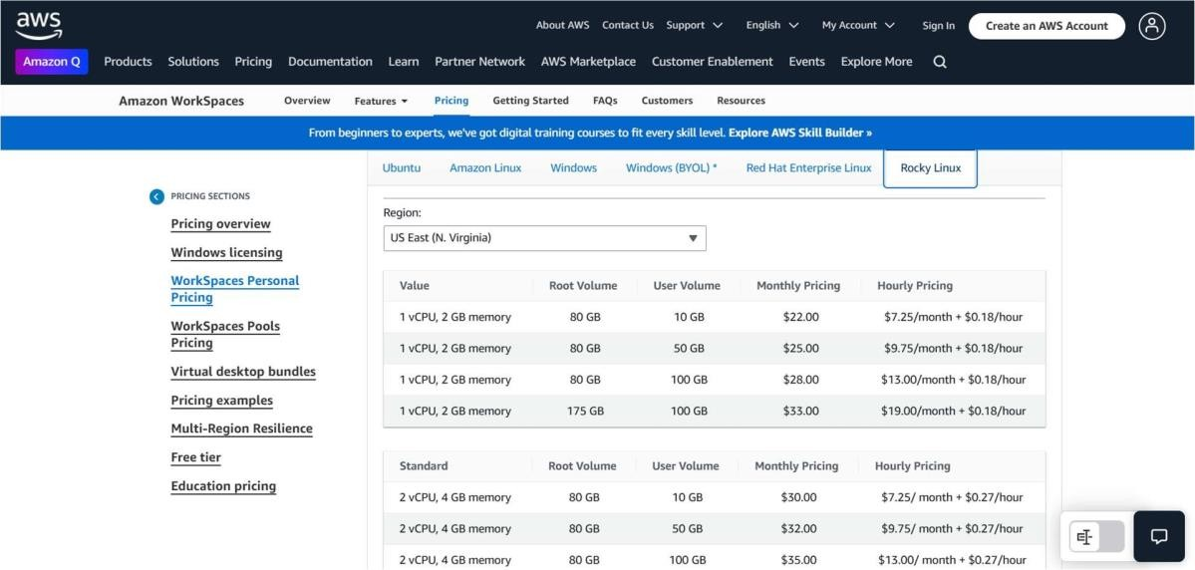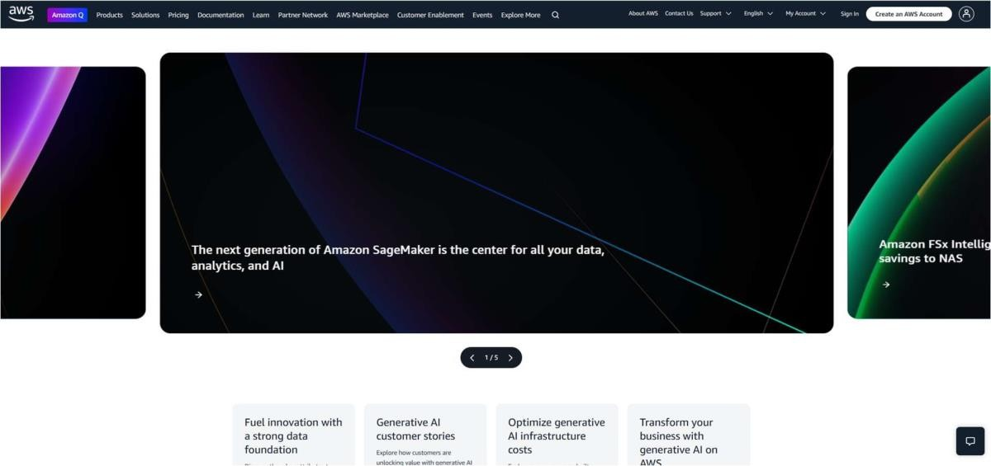

1. **NeverInstall**
   * **Website**: neverinstall.com
   * **Overview**: NeverInstall is a **cloud desktop** platform that allows users to access applications directly through a browser without installation. It provides a **free plan** and a **premium plan** for additional resources.

# Key Features:

* + - **Free Plan** available with basic apps and resources.
    - **No installation** needed; access apps directly in the browser.
    - Includes popular apps like **VSCode**, **Photoshop**, and **Google Chrome**.
    - Easy to set up and use, works across various devices.
  + **Target Audience**: Ideal for **individuals**, **students**, or **small businesses**.

# Pricing:

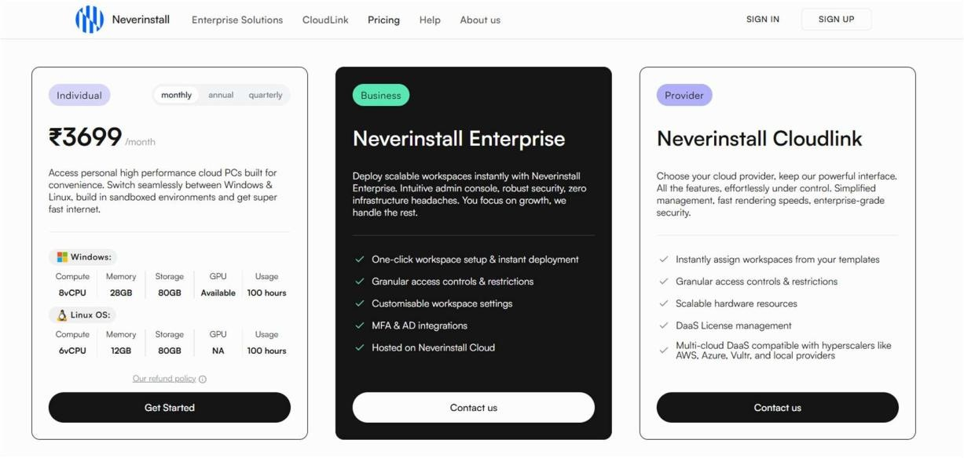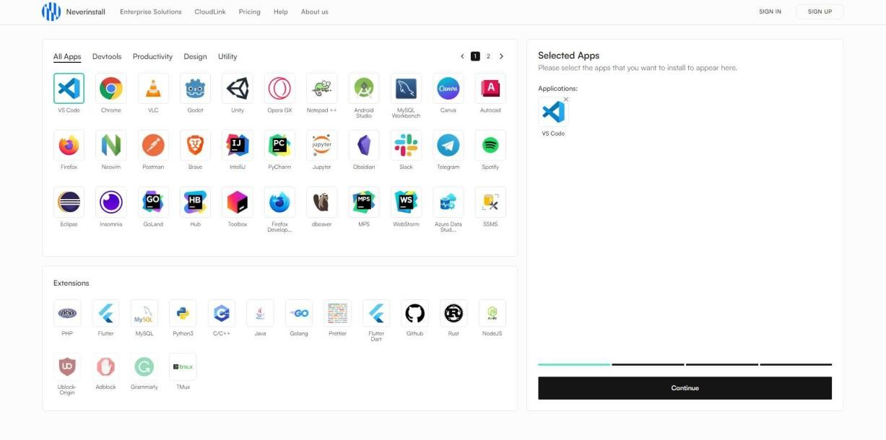

1. **KasmWeb**
   * **Website**: kasmweb.com
   * **Overview**: KasmWeb provides **containerized virtual desktops** and applications via the browser. It offers **secure, scalable environments** for businesses and organizations.

# Key Features:

* + - **Demo Version** for **3 minutes**.
    - **Containerized environments** for secure app delivery.
    - **End-to-end encryption** and isolated sessions for security.
    - Suitable for **enterprise-level deployments**.
  + **Target Audience**: Primarily for **businesses** and **enterprises** requiring secure remote access.
  + **Pricing**: Free 3-minute demo, with **enterprise-level pricing** for full access.

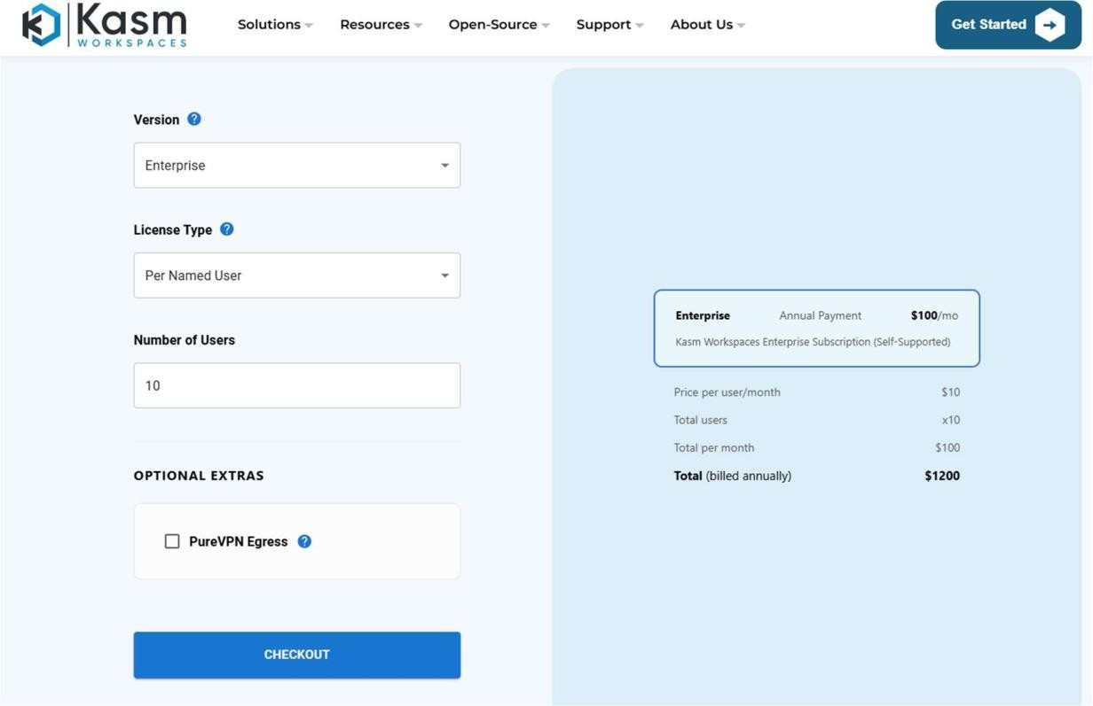

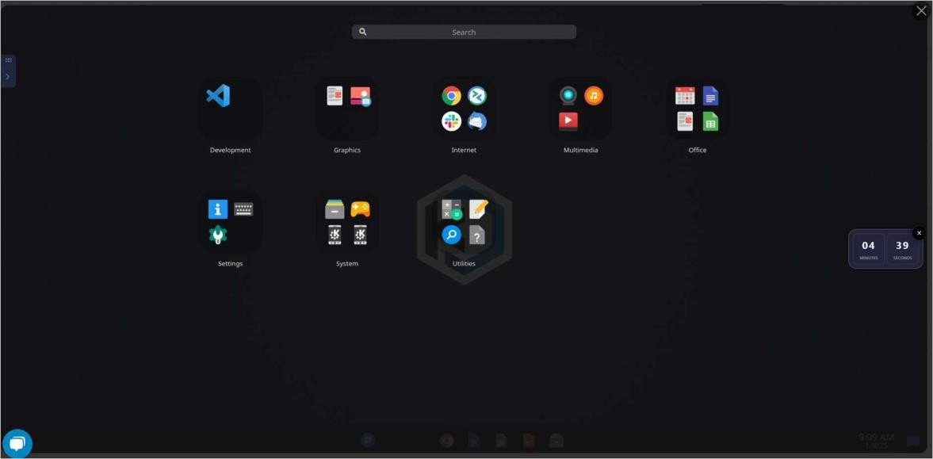

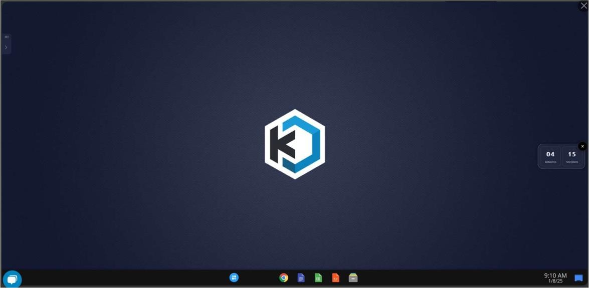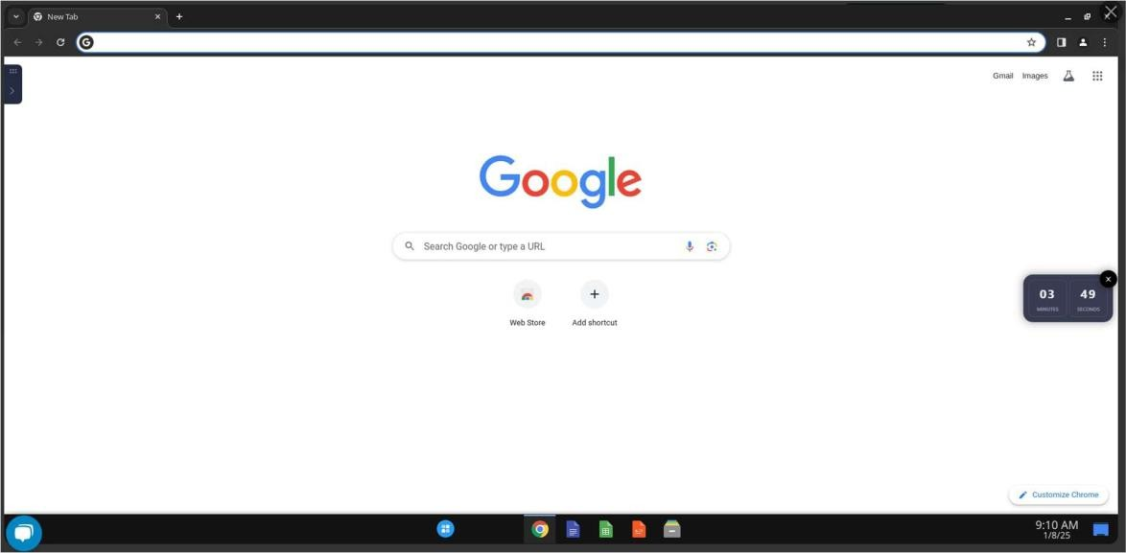

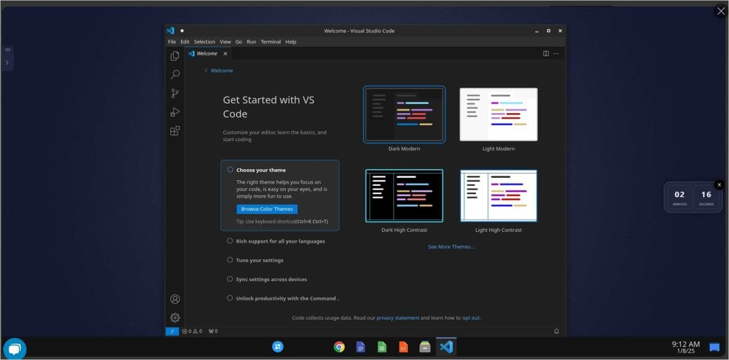

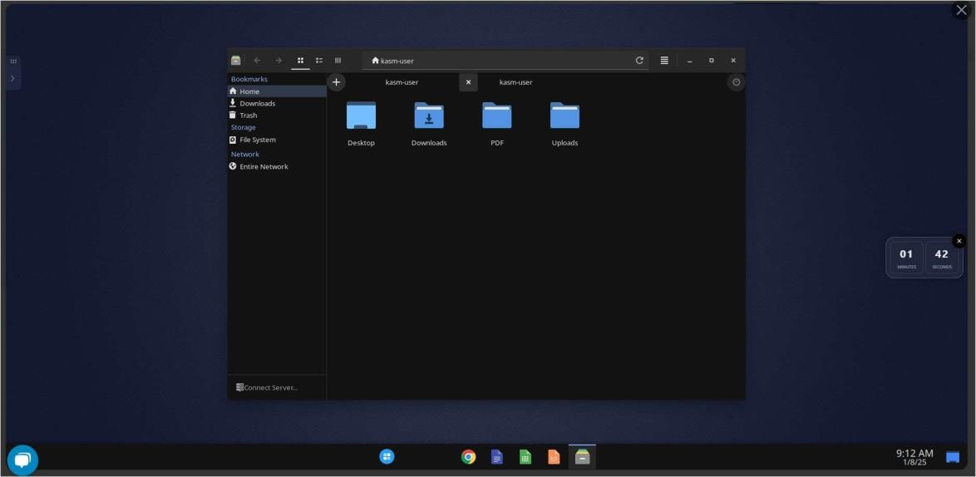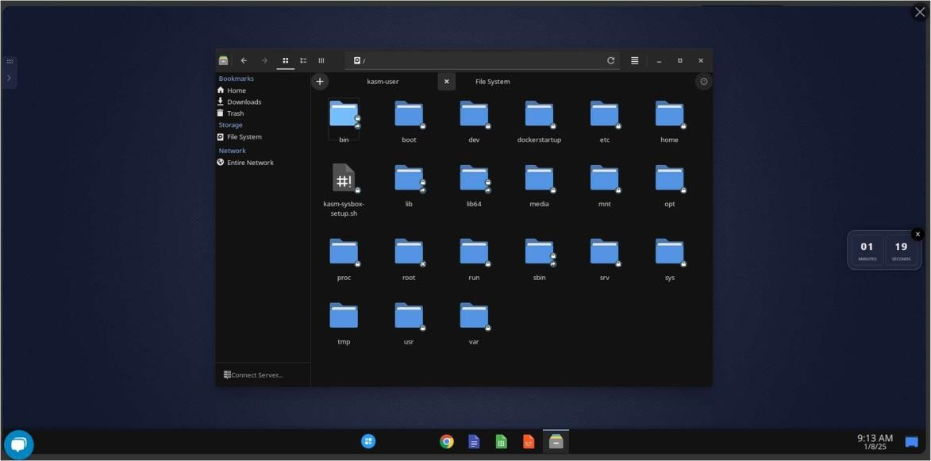

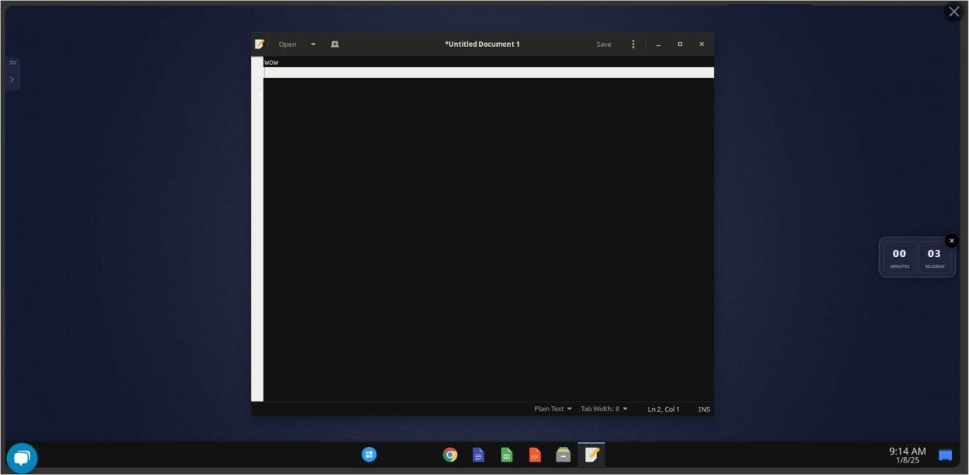

**Comparative Analysis Table:**

|  |  |  |  |  |  |  |  |  |
| --- | --- | --- | --- | --- | --- | --- | --- | --- |
| **Feature** | **Cloud Top** | **Cloud Me** | **Qube s OS** | **Univers eOS** | **UbiDes ktop** | **Amazon Worksp**  **aces** | **Neverin stall** | **Kasmw eb** |
| **Price** | Varies (Paid) | Free/P aid | Free | Free/Pai d | Free/Pai d | Pay-as- you-go (From  $7) | Pay-as- you-go (From  $5) |  |
| **Mobile App Availab**  **ility** | Yes | Yes | No | Yes | Yes | Yes | Yes |  |
| **Storage Space** | Varies | 20GB  Free | VM-  based | Customi zable | Customi zable | Customi  zable (AWS) | 5GB  Free | Customi  zable (AWS) |
| **User Interfa ce (UI)** | Clean, Simple | Basic | Secur ity- focus  ed | Customi zable | Simple | Customi zable | Minima list, Web-  based |  |
| **Sharing Capabil ities** | Social Media, Mail | Social Media  , Mail | No Shari ng | Mail | Mail | Enterpri se-level (via  AWS) | Social Media, Mail |  |
| **Chat Facility** | Yes | No | No | No | No | Yes (AWS  Chime) | Yes  (Web- based) |  |

**Compare and contrast between Daas and Iaas:**

|  |  |  |
| --- | --- | --- |
| **Criterion** | **DaaS (Desktop-as-a-Service)** | **IaaS (Infrastructure-as-a-**  **Service)** |
| **Core Offering** | Provides **virtual desktops** with full OS and apps. | Provides **virtualized**  **infrastructure** (VMs, storage, networking). |
| **Use Case** | Primarily for **remote desktop access**, ideal for **remote work**, education, and temporary  workers. | Used for **hosting applications**, **websites**, and **databases**, and creating development  environments. |
| **Customization** | Limited customization (e.g.,  installing apps within the virtual desktop). | High customization (users can  install any OS and configure infrastructure as needed). |
| **Management Responsibility** | Managed by the provider (including OS, apps, and  desktop management). | Managed by the customer (users configure and maintain VMs,  software, and security). |
| **Target Audience** | Businesses needing **virtual**  **desktop access** for users (e.g., remote workers, contractors). | Businesses needing **flexible**  **infrastructure** for running apps, databases, or complex workloads. |
| **Pricing Model** | **Subscription-based pricing**  (per user/desktop or virtual desktop usage). | **Pay-as-you-go pricing** based on  resource consumption (compute, storage, network). |